Title:

An ant-dispersed plant community recovers following three-year removal of elaiosomes in a Connecticut forest

Author(s):

Robert Emerson Clark1,2

1Great Hollow Nature Preserve and Ecological Research Center

2EcoData Technology LLC

Corresponding email:

rclark@greathollow.org

Abstract:

Food-for-dispersal mutualisms are critical sources of energy flow in ecological networks. By providing a nutrient-rich reward in the form of a fruit or seed to an animal mutualist plants gain directed dispersal. Myrmecochory is one form of animal-mediated seed dispersal in which ants are recruited to plant seeds by providing a nutrient rich appendage called an elaiosome. It is unclear to what impact nutrients provided by elaiosomes have on ants, and whether the mutualism can tolerate disruptions to this food source. In the Northeastern U.S. mixed deciduous forest ecoregion, a diverse assemblage of herbaceous plants are dispersed by the facultative mutualist ants *Aphaenogaster.* Since *Aphaenogaster* ants gain a significant nutrient subsidy from this mutualism, it is predicted that loss of these seeds could cause reductions in their population size. To test this hypothesis, I performed a long-term, small-scale removal of all elaiosomes-bearing diaspores in a gridded plot in a forest understory dominated by myrmecochores. From April to May from 2010 to 2012, all seeds were removed by hand from three 50m2 plots, each paired with control plots with no removal, and a supplementation plot with *Trillium erectum*. I collected data on proportional coverage of ant-dispersed plants and the abundance of seed-dispersing ants relative to the entire ant community. I found that despite entirely removing three growing seasons worth of elaiosomes, there were modest reductions in the proportional coverage of ant-dispersed plants. Ant communities were not impacted or had made a recovery within the multi-year duration of the experiment. In this experiment, evidence that *Aphaenogaster* were limited by elaiosomes was limited, supporting more recent research indicating that population densities are not constrained by the availability of myrmecochores. As long as surrounding populations of understory forest plants are maintained, both mutualistic ants and ant-dispersed plant communities have a robust ability to rebound from a reduction in this food source.

Key words: Mutualism, Dispersal ecology, Ants, Ant-dispersed plants, Forest food webs

Introduction

Seed dispersal mutualisms are important components of terrestrial food webs since they represent a source of energy flow from plants to animals (Bascompte and Jordano 2007, Schleuning et al. 2015, Vader Wall et al. 2017). By providing a food source to animals in the form of fruit or seed tissue, plants can achieve directed dispersal to high-quality sites, while animal seed dispersers gain a high-quality food source (Silva et al. 1997, Farwig and Berens 2012). Ant-dispersed plants present a syndrome of traits to recruit ant workers to seeds (Giladi 2006, Dunn et al. 2007). These “myrmecochores” are a diverse group of over 11,000 species with this dispersal strategy, and they produce diaspores with soft, lipid-rich appendages called elaiosomes (Warren and Giladi 2014). Elaiosomes are attractive to ants, and foraging workers return the seeds to the parent colony, remove the elaiosomes to feed to brood, and then discard the remaining seed to ant colony middens (Morales and Heithaus 1998). Elaiosomes contain multiple nutrients that can be limiting for ant colony development, including fats and amino acids (Fischer et al. 2005). High abundance of both ant-dispersed plants and ants in some habitats suggest this is an important limiting food source for ant populations, especially given that elaiosomes nutritional quality seems to match the nutritional needs of developing ant larvae (Fischer et al. 2008). It is predicted that elaiosomes-bearing plants should have trophic impacts on ants by increasing population size of dispersing ants when available. However, tests of this “elaiosome-limitation hypothesis” are rare (but see Warren et al. 2018). Mechanistic work on the nutritional benefits of elaiosomes have focused on ant colony traits or fitness (e.g. Bono and Heithaus 2002, Gammans et al 2005), rather than ant population-level abundance in field conditions.

Myrmecochory is common in temperate forest understory plants for spring-ephemeral and summer-ephemeral life history strategies (Beattie and Culver 1981, Boulay et al. 2007). These relatively small flowering plants have short leafing and flowering times, often completing emergence, pollination, and seed production before the forest canopy closes. In eastern North American habitats, *Aphaenogaster* ants are numerically dominant, and evidence suggests these are the most effective dispersal mutualist for myrmecochores. *Aphaenogaster* ants rapidly discover and move diaspores (Smith et al. 1989), which prevents seed predation (Heithaus 1981, Ruhren and Dudash 1996). Given the ubiquity of these ants, the “eliaiosome-limitation hypothesis” has been primarily tested in this system (e.g. Warren et al. 2019). In particular, elaiosomes as a supplemental food source for *Aphaenogaster* colonies and can be important when insect prey is less available (Clark and King, 2012).

Demonstrating whether or not seed dispersing ants are limited by the availability of elaiosomes as a food source is an important question for the protection of this mutualistic community. Given the specificity of this mutualism, there is concern that habitat disturbance and fragmentation could negatively impact myrmecochorous communities or their seed-dispersing ants like *Aphaenogaster* (Ness and Morin 2008, Parker et al. 2021). Myrmecochores in these systems are predominantly spring ephemerals and seasonal greens that can dominate the herbaceous plant layer in intact closed-canopy mixed-deciduous forests (Handel et al. 1981). However, in smaller forest fragments, edge effects might drive reduced abundance of myrmecochores and seed-dispersing ants (Ness and Morin 2008). With the loss of these food sources due to habitat fragmentation, there could be cascading effects driving decline of this putative mutualist ant *Aphaenogaster*.

The goal of this study was two-fold: First, to describe the diversity of ant-dispersed plants in the understory of Connecticut forests. In the study area of this experiment (New Haven, Hartford, and Litchfield Co., Connecticut, USA), there is not a comprehensive list of ant-dispersed plants nor data on the relative abundance of these plants in forest understories. Second, since long-term data on ant-myrmecochore interactions are limited (Heinken and Winkler, 2009), I tested of the “elaiosome-limitation hypothesis” in an environment in which myrmecochores dominate. Moreover, there are relatively few studies indicating the importance of elaiosomes for maintaining populations of *Aphaenogaster* over multiple years,particularly in the context of the ability of this mutualistic community to tolerate disturbance.

Methods:

*Surveys and description of Connecticut ant-dispersed plants*

I reviewed the literature on herbaceous myrmecochorous plants, searching for species with known records in Connecticut forests that are native, non-woody, non-graminoid plants. I queried Web of Science with the search terms “myrmecochor*”, “elaiosome*”, and “ant” + “dispersed” + “plant”. Reviewing the abstract, I verified if the study was about ant-dispersed plants and created a list of species found in studies conducted in eastern North America. With this species list, I used online references, including the New England region maps on GoBotany.com (Native Plant Trust, 2021), to see which plant species had distributions including any Connecticut counties. Connecticut myrmecochores were included in Table 1 if studies validated ant dispersal through behavioral observation of seed removal (e.g. Gaddy 1986), or nutritional assays in which ants consumed elaiosomes (e.g. Bono and Heithaus 2002). Additionally, plants seen during surveys or while collecting seeds for Clark and King et al. 2012 were checked with-in the literature. These species lists were also checked following the same approach as the literature review. To be added to Table 1, evidence of behavioral observation or feeding were necessary (e.g. Robertson 1987, Warren and Bradford 2014). The genus *Viola* has been systematically revised since most reports of ant dispersal were published (e.g. Culver and Beattie, 1978). Thus, *Viola* reported in Table 1 were updated to reflect current names on GoBotany.com (Native Plant Trust, 2021).

In 2009-2010, I completed four surveys on ant-dispersed plant abundance in secondary forests. The goal of these surveys was to provide preliminary data on the most common species found across a range of secondary forests typical to the state of Connecticut, and to find a location in which ant-dispersed plants numerically dominate the understory plant community. At each site, I measured the coverage over our transect lines in cm and identified all non-graminoid herbaceous plants to species. I predicted that locations in which myrmecochores were exceptionally abundant would represent areas where the carrying capacity of *Aphaenogaster* could be manipulated if this pulse of nutrients was consistently found at high frequency.

*Simulating a small-scale disturbance trail at Henry Buck Trail*

We chose to the habitat manipulation at a site where all members of the myrmecochore complex easily found in Connecticut were present (Henry Buck Trail, Fig. S1). In 2010, 2011, and 2012, I removed all apparent seedpods and flowers of ant-dispersed plant species in April-May each year (one visit each month). Treatments were arranged in a 3x3 factorial design with three replicates for each treatment. Given density estimates of April 2010 preliminary transects, for removal treatment, I approximately harvested >155,000 flowers or seed pods over the three-year manipulation. In a third treatment, I supplemented plots with all *Trillium* seed pods that were extracted from removal treatments. *Trillium* has large, apparent seeds in which ants remove elaiosomes (personal observations, Gunther and Lanza 1989). *Trillium* supplementation was used as an opportunistic test if a single species can impact ant populations or if supplementation can change the coverage of *Trillium* long term. Furthermore, *Trillium erectum* is not clearly ant dispersed and sometimes considered as vertebrate dispersed in myrmecochore surveys (Handel et al. 1981), so this was an opportunity to test if the elaiosomes had any impact on ant density long-term as an indirect test.

Three years of elaiosomes removal deprived colonies located within these transects for a long-term period. The time period represents a long-term exclusion for this nutritional resource, and it would be difficult for *Aphaenogaster* in these plots to collect many elaiosomes given that their one m2 foraging territory is significantly smaller than the plots (Lubertazzi, 2011). The six year period represents the time in which new colonies could be produced and develop given that it *Aphaenogaster* colonies have a median lifespan of eight years, and new colony development could take up to two years (Lubertazzi, 2011). I measured foraging activity of ants to determine colony counts using cookie baits (modified from Lubertazzi, 2011, Mitchell et al. 2002).

*Statistical methods:*

Three approaches were used to statistical analysis in R version 4.0.5 (R working group, 2021). For analysis of proportional plant coverage at Henry Buck, I constructed a Generalized Linear Mixed Models (GLMMs) using the lme4 package (Bates et al. 2015), and model estimates were extracted using the emmeans package (Lenth 2016). P-values for fixed effects were calculated using the car package (Fox and Weisberg 2011). To evaluate treatment effects on ant colony abundance, as measured by recruitment to baits, a Kruskal-Wallis rank test was employed due to the highly non-normal structure of these data (Ruxton and Beauchamp 2008). For analysis of species richness (estimated site-specific rarefaction) and non-metric-multidimensional scaling (NMDS) of community composition, I used the vegan package (Osksanen et. al. 2019).

Results:

My literature and field surveys revealed there are 25 records of native, herbaceous, ant-dispersed plants following our search criteria. Overall, this indicates there is a rich assemblage of ant-dispersed plants found in Connecticut ecosystems, and these are predominantly native spring ephemerals found in the region’s mixed-deciduous forests. My surveys validated that many of these species can be common components of secondary forests. The species richness and composition of the plant communities surveyed is reported in supplemental tables and figures S1-S4, with Trout lily *(Erythronium americanum*) being the only myrmecochore species found at all sites. Notably, line transects revealed that the highest % cover of ant-dispersed plants was observed at the Henry Buck Trail at American Legion State Forest in Barkhamsted, CT (Fig S1). Myrmecochore species richness and coverage was noticeably higher than estimates from larger region-wide surveys (Warren et al. 2021). Thirteen myrmecochore species occurring in this site’s transect and a percent coverage for myrmecochores of 87.2% within the herbaceous layer.

Spring 2017 surveys of the plant community demonstrate ant-dispersed plants still dominated the proportional cover of the understory, herbaceous layer. Dutchman’s breeches (*Dicentra cucullaria*), Red trillium (*Trillium erectum*), Spring beauty (*Claytonia virginica*), and Trout Lily (*Erythronium americanum*) were the four most abundant ant-dispersed plants at the end of this survey (Fig. 1). Our historical removal treatments significantly reduced the proportional coverage of all ant-dispersed plants compared to non-ant-dispersed plants (Fig 2, Binomial GLMM, χ2 = 16.85, df = 2, *P* < 0.001). Control plots with no manipulation had the highest proportional coverage of ant-dispersed plants (Fig. 2, Tukey HSD). In terms of magnitude of this effect, 73.8% of the transects in control plots were covered by ant-dispersed plants, compared to 67.3% in removal plots, indicating they were still dominant in terms of leaf area. *Trillium* supplementation plots did not result in increased numbers of *Trillium* plantscompared to controls (Negative binomial GLMM, posthoc test, *Z* ratio = -1.265, *P* = 0.414). Plots with addition of *Trillium* seeds to plots had intermediate proportional covered by ant-dispersed plants overall (Fig. 2, Tukey HSD). At the community-wide level, I observed no significant change in the composition of the plant community when applying NMDS across all herbaceous plant species (NMDS, Permutation test for treatments, *r*2 = 0.0218, *P* = 0.329). In all, these results suggest that the manipulation only moderately reduced the proportional abundance of myrmecochores, and they remained dominant over non-myrmecochores and plots did not exhibit differences in community-wide species composition.

2017 baits used to record the ground-foraging ant community and *Aphaenogaster* colony abundance yielded five species of ants, including *Aphaenogaster rudis* group, *Camponotus pennsylvanicus*, *Lasius neoniger*, *Myrmica punctiventris,* and *Tapinoma sessile*. This sample event following three-years of myrmecochore removal and a six-year waiting period. I observed no difference in the abundance of seed-dispersing *Aphaenogaster* colony abundance among removal, control, or supplementation treatments (Fig. 3, Kruskal-Wallis, χ2 = 1.15, df = 2, *P* = 0.56). *Aphanogaster* workers were present at every observed bait in the removal treatment, additionally indicating they were abundant in these plots. Additionally, there was no difference among treatments in the recruitment of non-*Aphaenogaster* ants to these baits (Fig. 3, Kruskal-Wallis, χ2 = 0.78, df = 2, *P* = 0.67).

Discussion:

The impacts of human disturbance continue to disrupt dispersal mutualisms (Markl et al. 2012). Specialized mutualisms are particularly susceptible to extinctions because if one partner is extirpated from an environment, the mutualistic partner risks demographic failure (Farwig and Berens, 2012). My results indicate that in intact forests, even fragmented habitats like those seen in the Northeastern U.S., ant-myrmecochore mutualisms have a robust ability to tolerate small scale disturbance. If three years of seed crop are lost to environmental upset, I observed that myrmecochores are still able to persist dominant member of the understory, herbaceous plant community. Conversely, large-scale disturbance that leads to forest lost, and then subsequent re-establishment, may require longer time scales for recovery of ant-dispersed plants (Sorrells and Warren, 2001). While the mechanisms of disturbance tolerance are unclear, there is mounting evidence that myrmecochore-dispersing ants are not population limited by this mutualism. For example, surveys show that *Aphaenogaster* are probably not elaiosome-limited in small forest fragments compared to larger fragments (Mitchell et al. 2002). Likewise, I observed no change in the recruit of *Aphaenogaster* workers to baits during our sampling process, matching findings from (Warren et al 2019) in which removal of elaiosome-bearing plants did not reduce *Aphaenogaster* abundance. Closer analysis of nutrition acquisition from elaiosomes show weak impacts on reproduction or sex allocation in colonies of seed-dispersing ants (Caut et al. 2013).

My experiment is limited due to the geographic focus on a single forest system. I intentionally chose a site where myrmecochore were abundant to test this hypothesis, but the impacts on *Aphaenogaster* for myrmecochore removal might be more severe in marginal habitats where myrmecochores are comparatively rare members of the understory plant community. For example, *Aphaenogaster* are less common on the edge of forest fragments as well as some of their plant mutualists (Ness and Morin, 2008). Furthermore, there is mounting evidence that habitat fragmentation and competing invasive species can disrupt dispersal mutualisms (Rodriguez-Cabal et al. 2012, Meadley Dunphy et al. 2016). Different ant-dispersed plants can stagger seed release throughout the season to avoid competition (Warren et al. 2014), a phenological pattern which could be disrupted by climate change if seed release and ant activity become asynchronous (Warren et al. 2010). While *Aphaenogaster* ants are resident arthropods in these environments, they may be depending on food sources arriving in the early spring when food sources can be scarce (Clark and King 2012), but this gap in food availability perhaps did not occur at the field site selected. One final explanation could be that the nutritional benefits of elaiosomes vary greatly among plant species, with some even producing elaiosome-mimics that cheat in this mutualistic interaction (Pfeiffer et al. 2010). It is unclear how prevalent elaiosomes mimicry is given only a limited number of elaiosomes on plant species have been evaluated for nutritional content.

Mutualism specialization is an important topic in seed dispersal biology. While myrmecochory seed-dispersal syndrome shows clear specialization for recruiting and attracting ants, there is less evidence that *Aphaenogaster* or other seed-dispersing ants are specialist dispersers. There is some argumentation that *Aphaenogaster rudis* is a keystone mutualist and required for dispersal of many myrmecochore species (Ness et al. 2009). With regards to the conservation of forest understory plants and spring ephemerals, it is encouraging to know that gaps in the availability of elaiosomes are unlikely to negatively impact *Aphaenogaster* populations alone. Recent large-scale surveys in eastern US forests showed ant-dispersed understory plants are not necessarily more dispersal limited than other dispersal modes (Warren et al 2021). In all, this study indicates that while elaiosomes represent a large pulse of nutrients for ants represented by a diversity of species found in the understory of Connecticut forests. Further work should investigate how changes to climate or large-scale disturbances might drive phenological mismatches or loss of *Aphaenogaster* from forest fragments.

Acknowledgements: I thank the staff at American Legion State Forest (Connecticut Department of Energy and Environmental Protection, Parks Division) for allowing me to tag and manipulate plants in Barkhampsted, CT. Josh King (University of Central Florida) provided guidance on the experimental plot layout. Multiple volunteers contributed to the laborious removal experiments, including Melissa Bernardo, Chris Berthiaume, Megan Clark, Joe McLaughlin, and Lauren Verner. Taiga Araki assisted with ant baits and ant-dispersed plant coverage surveys. Chad Seewagen (Great Hollow) and Vera Pfeiffer (Washington State University) provided helpful feedback on revisions of this manuscript.

References

Bascompte, J., Jordano, P., 2007. Plant-Animal Mutualistic Networks: The Architecture of Biodiversity. Annu. Rev. Ecol. Evol. Syst. 38, 567–593. <https://doi.org/10.1146/annurev.ecolsys.38.091206.095818>

Bates, D., Maechler, M., Bolker, B., Walker, S., (2015). Fitting linear mixed-effects models using lme4. J. Stat. Softw. 67, 1-48. <https://doi.org/10.18637/jss.v067.i01>

Beattie, A.J., Lyons, N., 1975. Seed dispersal in *Viola* (Violaceae): adaptations and strategies. Am. J. Bot. 62, 714–722. <https://doi.org/10.2307/2442060>

Beattie, A.J., Culver, D.C., 1981. The guild of myrmecochores in the herbaceous flora of West Virginia forests. Ecology 62, 107–115. <https://doi.org/10.2307/1936674>

Bellemare, J., Motzkin, G., Foster, D.R., 2002. Legacies of the agricultural past in the forested present: an assessment of historical land-use effects on rich mesic forests. J. Biogeogr. 29, 1401–1420.

Bono, J.M., Heithaus, E.R., 2002. Sex ratios and the distribution of elaiosomes in colonies of the ant, Aphaenogaster rudis. Insectes soc. 49, 320–325. <https://doi.org/10.1007/PL00012655>

Boulay, R., Coll-Toledano, J., Manzaneda, A., Cerdá, X., 2007. Geographic variations in seed dispersal by ants: Are plant and seed traits decisive? Sci. Nat. 94, 242–6. <https://doi.org/10.1007/s00114-006-0185-z>

Caut, S., Jowers, M.J., Cerda, X., Boulay, R.R., 2013. Questioning the mutual benefits of myrmecochory: a stable isotope-based experimental approach. Ecol. Entomol. 38, 390–399. <https://doi.org/10.1111/een.12028>

Clark, R.E., King, J.R., 2012. The ant, *Aphaenogaster picea*, benefits from plant elaiosomes when insect prey is scarce. Environ. Entomol. 41, 1405–1408. <https://doi.org/10.1603/en12131>

Culver, D.C., Beattie, A.J., 1978. Myrmecochory in *Viola*: Dynamics of seed-Ant interactions in some West Virginia species. J. Ecol. 66, 53–72. <https://doi.org/10.2307/2259181>

Dunn, R., Gove, A., Barraclough, T., Givnish, T., Majer, J., 2007. Convergent evolution of an ant-plant mutualism across plant families, continents, and time. Evol. Ecol. Res. 9, 1349-1362. <http://hdl.handle.net/20.500.11937/27347>

Farwig, N., Berens, D.G., 2012. Imagine a world without seed dispersers: a review of threats, consequences and future directions. Basic Appl. Ecol. 13, 109-115. <https://doi.org/10.1016/j.baae.2012.02.006>

Fischer, R.C., Richter, A., Hadacek, F., Mayer, V., 2008. Chemical differences between seeds and elaiosomes indicate an adaptation to nutritional needs of ants. Oecologia 155, 539–547. <https://doi.org/10.1007/s00442-007-0931-8>

Fischer, R.C., Ölzant S.M., Wanek W., Mayer V., 2005. The fate of *Corydalis cava* elaiosomes within an ant colony of *Myrmica rubra*: elaiosomes are preferentially fed to larvae. Insectes Soc. 52, 55-62.

Fox, J., Weisberg, S., 2011. An R Companion to Applied Regression. Sage Publications, Thousand Oaks, California.

Gammans, N., Bullock, J.M., Schönrogge, K., 2005. Ant benefits in a seed dispersal mutualism. Oecologia 146, 43–49. <https://doi.org/10.1007/s00442-005-0154-9>

Gaddy, L.L., 1986. Twelve new Ant-dispersed species from the Southern Appalachians. Bull. Torrey Bot. Club. 113, 247–251. <https://doi.org/10.2307/2996363>

Gibson, W., 1993. Selective advantages to hemi-parasitic annuals, genus *Melampyrum*, of a seed-dispersal mutualism involving ants: I. favorable nest sites. Oikos 67, 334–344. <https://doi.org/10.2307/3545480>

Giladi, I., 2006. Choosing benefits or partners: a review of the evidence for the evolution of myrmecochory. Oikos 67, 334-344. <https://doi.org/10.1111/j.0030-1299.2006.14258.x>

Gunther, R.W., Lanza, J., 1989. Variation in attractiveness of *Trillium* diaspores to a seed-dispersing ant. Am. Midl. Nat. 122, 321–328. <https://doi.org/10.2307/2425919>

Handel, S.N., Fisch, S.B., Schatz, G.E., 1981. Ants disperse a majority of herbs in a mesic forest community in New York state. Bull. Torrey Bot. Club. 108, 430–437. <https://doi.org/10.2307/2484443>

Heinken, T., Winkler, E., 2009. Non-random dispersal by ants: Long-term field data versus model predictions of population spread of a forest herb. Perspect. Plant Ecol. Evol. 11, 1–15. <https://doi.org/10.1016/j.ppees.2008.11.001>

Heithaus, E.R., 1981. Seed predation by rodents on three ant-dispersed plants. Ecology 62, 136–145. <https://doi.org/10.2307/1936677>

Lenth, R.V., 2016. Least-Squares Means: The R package lsmeans. J. Stat. Softw. 69:1-33.

Lubertazzi, D., 2012. The Biology and Natural History of Aphaenogaster rudis. Psyche 2012, e752815. <https://doi.org/10.1155/2012/752815>

Ness, J.H., Morin, D.F. Giladi, I., 2009. Uncommon specialization in a mutualism between a temperate herbaceous plant guild and an ant: Are *Aphaenogaster* ants keystone mutualists? Oikos 118, 1793-1804. <https://doi.org/10.1111/j.1600-0706.2009.17430.x>

Ness, J.H., Morin, D.F., 2008. Forest edges and landscape history shape interactions between plants, seed-dispersing ants and seed predators. Biol. Conserv. 141, 838–847. <https://doi.org/10.1016/j.biocon.2007.12.029>

Markl, J.S., Schleuning, M., Forget, P.M., Jordano, P., Lambert, J.E., Traveset, A., Wright, S.J., Böhning-Gaese, K., 2012. Meta-analysis of the effects of human disturbance on seed dispersal by animals. Conserv. Biol. 26, 1072–1081. <https://doi.org/10.1111/j.1523-1739.2012.01927.x>

Meadley Dunphy, S.A., Prior, K.M., Frederickson, M.E., 2016. An invasive slug exploits an ant-seed dispersal mutualism. Oecologia 181, 149–159. <https://doi.org/10.1007/s00442-015-3530-0>

Miller, J.M., Chambers, K.L., 2006. Systematics of *Claytonia* (Portulacaceae). Syst. Bot. Monogr. 78, 1–236. <http://dx.doi.org/10.2307/25027952>

Mitchell, C.E., Turner, M.G., Pearson, S.M., 2002. Effects of historical land use and forest patch size on myrmecochores and ant communities. Ecol. Appl. 12, 1364–1377. <https://doi.org/10.2307/3099977>

Morales, M.A., Heithaus E.R., 1998. Food from seed-dispersal mutualism shifts sex ratios in colonies of the ant *Aphaenogaster rudis*. Ecology 79, 734-739. [https://doi.org/10.1890/0012-9658(1998)079[0734:FFSDMS]2.0.CO;2](https://doi.org/10.1890/0012-9658(1998)079%5b0734:FFSDMS%5d2.0.CO;2)

Native Plant Trust. 2021. Go Botany [WWW Document]. URL <https://www.gobotany.nativeplanttrust.org> (accessed 12.13.2021).

Oksanen, J., Blanchet, F.G., Friendly, M., Kindt, R., Legendre, P., McGlinn, D., Minchin, P.R., B, R., O’Hara, G., Simpson, L., Solymos, P., Henry, M., Stevens, H., Szoecs, E., Wagner, H., 2019. vegan: Community ecology package. R package version 2.5-5. <https://CRAN.R-project.org/package=vegan>

Parker, W.J., Buono, C.M., Prior, K.M., 2021. Antagonistic and mutualistic interactions alter seed dispersal of understory plants at forest edges. Ecosphere 12, e03397. <https://doi.org/10.1002/ecs2.3397>

Pfeiffer, M., Huttenlocher, H., Ayasse, M., 2010. Myrmecochorous plants use chemical mimicry to cheat seed-dispersing ants. Funct. Ecol. 24, 545–555. <https://doi.org/10.1111/j.1365-2435.2009.01661.x>

Ruhren, S., Dudash, M., 1996. Consequences of the timing of seed release of *Erythronium americanum* (Liliaceae), a deciduous forest myrmecochore. Amer. J. Bot. 83, 633-640. <https://doi.org/10.2307/2445923>

Ruxton, G.D., Beauchamp, G., 2008. Some suggestions about appropriate use of the Kruskal-Wallis test. Anim. Behav*.* 76, 1083-1087.

Robertson, C., 1897. Seed Crests and myrmecophilous dissemination in certain plants. Bot. Gaz. 23, 288–289. <https://doi.org/10.1086/327511>

Rodriguez-Cabal, M.A., Stuble, K.L., Guénard, B., Dunn, R.R., Sanders, N.J., 2012. Disruption of ant-seed dispersal mutualisms by the invasive Asian needle ant (*Pachycondyla* *chinensis*). Biol. Invasions 14, 557–565. <https://doi.org/10.1007/s10530-011-0097-5>

Schleuning, M., Fründ, J., García, D., 2015. Predicting ecosystem functions from biodiversity and mutualistic networks: an extension of trait-based concepts to plant-animal interactions. Ecography 38, 380–392. <https://doi.org/10.1111/ecog.00983>

Silva, M., Brown, J.H., Downing, J.A., 1997. Differences in population density and energy use between birds and mammals: A Macroecological Perspective. J. Anim. Ecol. 66, 327–340. <https://doi.org/10.2307/5979>

Smith, B.H., deRivera, C.E., Bridgman, C.L., Woida, J.J., 1989. Frequency-dependent seed dispersal by ants of two deciduous forest herbs. Ecology 70, 1645–1648. <https://doi.org/10.2307/1938098>

Sorrells, J., Warren II, R.J., 2011. Ant-dispersed herb colonization lags behind forest re-establishment. J. Torrey Bot. Soc. 138, 77–84. <https://doi.org/10.3159/10-RA-037.1>

Thompson, J.N., 1981. Elaiosomes and fleshy fruits: phenology and selection pressures for ant-dispersed seeds. The American Naturalist 117, 104–108. <https://doi.org/10.1086/283691>

Warren II, R.J., Bahn, V., Bradford, M.A., 2011. Temperature cues phenological synchrony in ant-mediated seed dispersal. Glob. Chang. Biol. 17, 2444–2454. <https://doi.org/10.1111/j.1365-2486.2010.02386.x>

Warren, R.J., Bradford, M.A., 2014. Mutualism fails when climate response differs between interacting species. Glob. Chang. Biol. 20, 466–474. <https://doi.org/10.1111/gcb.12407>

Warren II, R.J., Giladi, I., Bradford, M.A., 2014. Competition as a mechanism structuring mutualisms. J. Ecol. 102, 486–495. <https://doi.org/10.1111/1365-2745.12203>

Warren II, R.J., Giladi, I., 2014. Ant-mediated seed dispersal: A few ant species (Hymenoptera: Formicidae) benefit many plants. Myrmecological News 20, 129–140.

Warren II, R.J., Elliott, K.J., Giladi, I., King, J.R., Bradford, M.A., 2019. Field experiments show contradictory short- and long-term myrmecochorous plant impacts on seed-dispersing ants. Ecological Entomology 44, 30–39. <https://doi.org/10.1111/een.12666>

Warren II, R.J., Olejniczak, M., Labatore, A., Candeias, M., 2021. How common and dispersal limited are ant-dispersed plants in eastern deciduous forests? Plant Ecol. 222, 361–373. <https://doi.org/10.1007/s11258-020-01111-3>

Vander Wall, S.B., Barga, S.C., Seaman, A.E., 2017. The geographic distribution of seed-dispersal mutualisms in North America. Evol. Ecol. 31, 725–740. <https://doi.org/10.1007/s10682-017-9899-y>

Figure captions:

Table 1. List of ant-dispersed plants found in Connecticut forests. List generated from field surveys in Connecticut forests and literature review of empirical work on myrmecochory in the eastern U.S. Status of verified seed dispersal syndrome highlighted in each row, along with description of observation status. *Corydalis sempervirens*, *Dicentra canadensis*, *Trillum cernuum*, and *Viola rotundifolia* are putatively ant-dispersed and found in Connecticut counties, but no empirical evidence was found demonstrating ant recruitment to seeds. (1Former synonym with *Hepatica nobilis*, 2Elaiosome traits reported for all relatives in this genus).

Fig. 1. Experimental design for Henry Buck Trail plots and community-level survey results. Nine 50m2 plots were laid out in Spring 2009, followed by three years of exclusions across each plot. Circles represent the proportional abundance of plants in each category: four common myrmecochores (*Claytonia, Dicentra, Erythronium, Trillium*), other myrmecochores, and all non-myrmecochore herbaceous plants. Numbers indicate block #, and each pie-chart is labeled with the seed manipulation treatment. There was no significant difference in plant community composition across the three treatments (NMDS, Permutation test for treatments, *r*2 = 0.0218, *P* = 0.329).

Fig 2. Plot for binomial GLMM of % ant-dispersed plant cover out of all non-woody understory plants sampled (treatment as fixed effect, meter transects as random effects). Letters indicate post-hoc tests (Tukey HSD) across all treatment groups. Points indicate the estimated marginal means from the binomial GLMM and their associated error terms are represented by error bars.

Fig. 3. Violin plot for recruitment lines of workers found at baits in 2017 assay. Width of violin plots within each treatment indicates the relative number of counts of that number, while length indicates the range of observed outcomes (0-3 colonies per bait). Center points and error bars indicate mean and standard error of the mean.

Table 1.

|  |  |  |  |
| --- | --- | --- | --- |
| **Plant species** | **Common Name** | **Ant-dispersal reported** | **At Henry Buck Plot** |
| *Anemone americana*1 | Blunt-lobed hepatica | Warren and Bradford 2014 | X |
| *Anemone quinquefolia* | Wood anenome | Beattie and Culver 1981 | X |
| *Asarum canadense* | Canadian wild ginger | Smith et al. 1989 | X |
| *Claytonia caroliniana*2 | Carolina springbeauty | Miller and Chambers 2006 |  |
| *Claytonia virginica* | Eastern springbeauty | Handel et al. 1981 | X |
| *Corydalis flavula* | Yellow fumewort | Beattie and Culver 1981 |  |
| *Dicentra canadensis* | Squirrel corn | Thompson 1981 | X |
| *Dicentra cucullaria* | Dutchman's breeches | Handel et al. 1981 | X |
| *Erythronium americanum* | Trout lily | Ruhren and Dudash 1996 | X |
| *Galium circaezans* | Forest licorice | Gaddy 1986 |  |
| *Hepatica acutiloba* | Sharp-lobed hepatica | Handel et al. 1981 |  |
| *Melampyrum lineare* | American cow-wheat | Gibson 1993 |  |
| *Sanguinaria canadensis* | Bloodroot | Heithaus 1981 | X |
| *Trilium cernuum2* | Nodding trillium | Gunther and Lanza 1989 |  |
| *Trillium erectum* | Red trillium | Gunther and Lanza 1989 | X |
| *Trillium grandiflorum* | Great white trillium | Gunther and Lanza 1989 |  |
| *Trillium undulatum* | Painted trillium | Gunther and Lanza 1989 | X |
| *Uvularia grandiflora* | Large-flowered bellwort | Robertson 1897 |  |
| *Uvularia perfoliata* | Perfoliate bellwort | Beattie and Culver 1981 |  |
| *Viola blanda* | Sweet white violet | Culver and Beattie 1978 | X |
| *Viola canadensis* | Canada violet | Beattie and Lyons 1975 |  |
| *Viola palmata* | Wood violet | Culver and Beattie 1978 |  |
| *Viola pedata* | Birdfood violet | Culver and Beattie 1978 |  |
| *Viola pubescens* | Downy yellow violet | Culver and Beattie 1978 | X |
| *Viola rostrata* | Long-spurred violet | Culver and Beattie 1978 |  |
| *Viola sororia* | Common blue violet | Culver and Beattie 1978 | X |

Fig. 1.

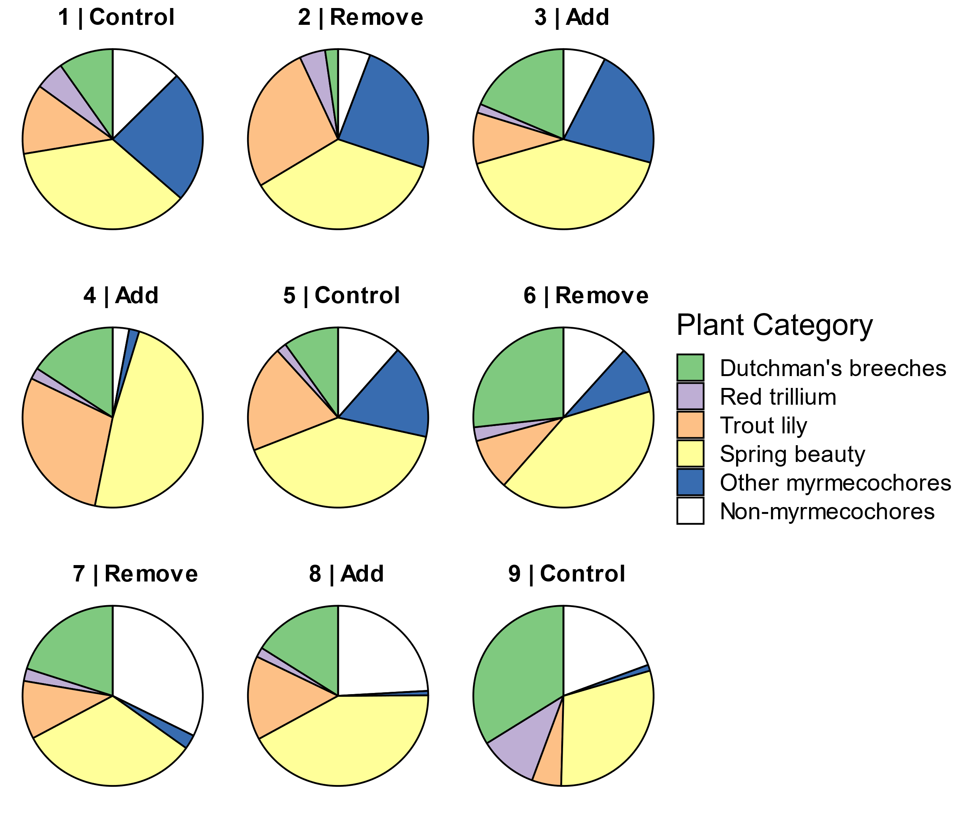

Fig 2.

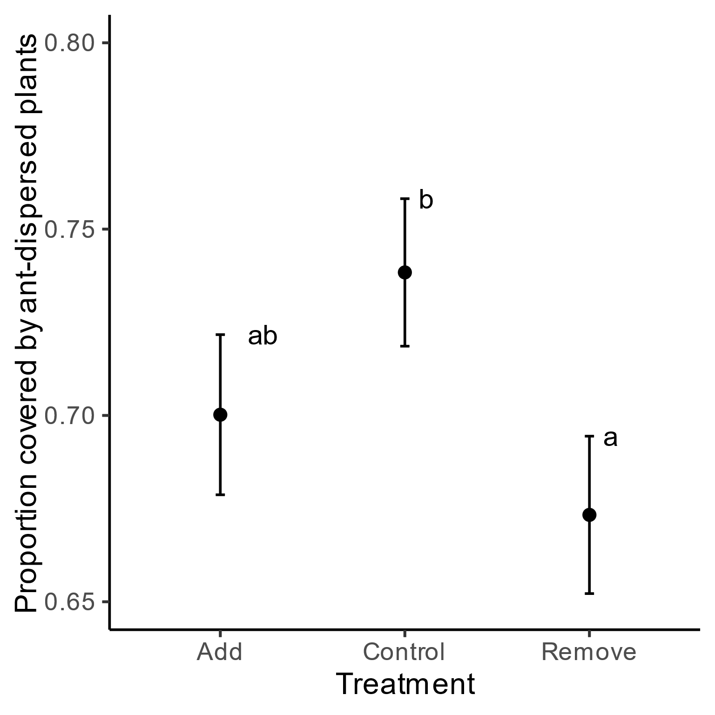

Fig. 3.

